

|  |  |
| --- | --- |
| **Name:Mohd Zaki Mehtab Qureshi** | **Course Name: SMA Lab** |
| **Assignment No: 1** | **Roll no: 19CO40** |

**1.Explain Social Media Analytics Cycle**

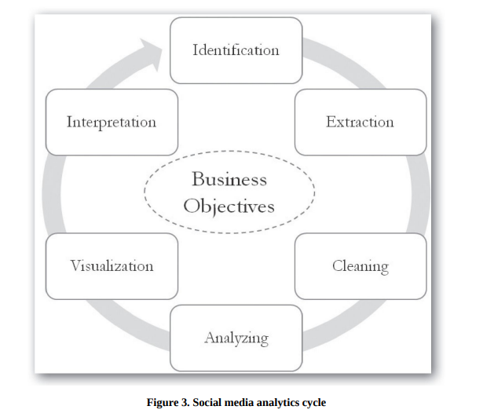

**Step1 - Identification**

The identification stage of social media analytics involves finding the right sources of data to analyze in order to gain valuable business insights.

**Step2 - Extraction**

The extraction stage of social media analytics involves using appropriate methods and tools to gather data from identified sources. This can include manual data collection for small-scale data and automated extraction using APIs (application programming interfaces) for larger data sets.

**Step3 - Cleaning**

The cleaning step in social media analytics involves removing unwanted data from the collected data set. This can involve processes such as coding, filtering, clustering, and natural language processing to remove irrelevant data.

**Step 4 - Analyzing**

The analyzing stage of social media analytics involves using clean data to identify valuable insights for the business. The approach and techniques used will depend on the type of data being analyzed and the tools and algorithms employed

**Step 5 - Visualization**

The visualization step in social media analytics involves creating visual representations of the results of the analysis

Visualization can help reveal hidden patterns, relationships, and trends in complex and large data sets

**Step 6 : Interpretation**

Interpret and translate analytics results into a meaningful business problem.

Two strategies or approaches used are:

1) Producing easily consumable analytical results and

2) Improving analytics consumption capabilities

**2.What are the Challenges to Social Media Analytics**

High Velocity

High Volume

High Diverse - Social media users and the content they generate are extremely diverse,multilingual, and vary across time and space.

Not every tweet, like, or user is worth looking at.

Unstructuredness as a challenge

**3.Describe the Networks Measures - Degree Distribution, Density, Connectivity, Centralization, Tie**

**Degree distribution:**

Degree distribution is a way to describe the distribution of degrees among the nodes in a network.

To create a degree distribution, the degree of each node in the network is calculated.

The next step is to count how many nodes have each degree and create a table or chart to display this information.

A bar graph is a common way to display a degree distribution, with the x-axis showing the degree and the y-axis indicating the number of nodes with that degree.

**Density:**

Density describes how connected a network is.It is a statistic comparing the number of edges that exist in a network to the number of edges that could possibly exist.

Consider the following two networks, which both have the same number of nodes.

Network (a) has very few edges while

Network (b) has numerous edges among the same number of nodes.

Network (b) has higher density.

**Connectivity**:

Density measures the percentage of possible edges in a graph. Connectivity, also known as cohesion, measures how those edges are distributed.

Connectivity is a count of the minimum number of nodes that would have to be removed before the graph becomes disconnected.

**Centralization:**

Centralization measures the extent to which the ties of a given network are concentrated on a single actor or group of actors.

C(n) be the centrality of node n, using whatever centrality measure we choose.

n* is the most central node.

Find the difference in centrality between n* and every other node in the network, and add those up.

**Tie:**

Tie Strength is the measure of the strength of the relationship between the people.

Strong Ties - rare , family members and close friends. Strong ties are more trusted and their information is more likely to be reliable.

Weak Ties - includes acquaintances and more casual relationships. Weak ties always connect to diverse groups of people with different perspectives.

Absent Ties - The people with whom we have no relations.

**4.Social Media Network Analytics - Common Network Terms, Common Social Media Network Types, Types of Networks, Common Network Terminologies, Network Analytics Tools.**

**Common network terms:**

NODE-LEVEL PROPERTIES

Degree Centrality

Betweenness Centrality

Eigenvector Centrality

NETWORK-LEVEL PROPERTIES

Clustering Coefficient - The clustering coefficient of a network is the degree to which nodes in a network tend to cluster or group together.

Density -Density can be calculated as the number of links present in a network divided by the number of all possible links between pairs of nodes in a network

Components -Components of a network are the isolated sub-networks that connect within, but are disconnected between, sub-networks.

Diameter -The diameter of a network is the largest of all the calculated shortest path between any pair of nodes in a network

Average Degree -The average degree centrality measures the average number of links among nodes in a network.

**Common social media networks:**

Friendship network

Follow-Following Network

FAN Network

Group Network - people who share common interests and agendas.eg. Yahoo Groups, Facebook Groups

Professional Networks - Nodes in these networks are, for example,

people, brands, and organizations, and links are professional relations (such as

coworker, employee, or collaborator). An important feature of professional

networks is the endorsement feature, where people who know you can endorse

your skills and qualifications.

Dating Network

Co authorship Network

Hyperlink Network

COLIKE -colike networks are formed when two or more people like the

same social media content.

COCOMMENTER NETWORKS

Cocommenter networks are formed when two or more people comment on socialmedia content (e.g., a Facebook status update, blog post, or YouTube video).

Nodes represent users, and link represents the cocommenting relationship.

**Types of network:**

BASED ON EXISTENCE -

Implicit (keyword co occurrence networks, co citation networks, cocommenter networks, hyperlink networks)

Explicit network- (keyword cooccurrence networks, cocitation networks, cocommenter networks, hyperlink networks)

BASED ON DIRECTION

1) directed networks

2) undirected networks.

BASED ON MODE

Based on the composition of nodes, networks can be classified as

1) One-mode network - A one-mode network is formed among a single set of nodes of the same nature . A Facebook friendship network is an example of a one-mode

network where nodes (people) form network ties (friendships).

2) Two-mode networks - Two-mode networks (also known as bipartite networks) are networks with two sets of nodes of different classes.one set of nodes (circles) could be social media users and other set of

nodes (squares) could be participation in a series of events. Users are linked to

the events they attended.

3) Multimode networks.

BASED ON WEIGHTS

1) weighted networks,

2) unweighted networks.

**Network analytic tools:**

NodeXL: A free tool for social network analysis and visualization for networks on platforms like Facebook, Twitter, and YouTube.

UCINET: A social network analysis software for Windows operating system with a free 90-day trial.

Pajek: A software application for analyzing and visualizing large networks, free for non-commercial use on Windows operating systems.

Netminer: A software application for large social network analysis and visualization, with a free 28-day trial.

Flocker: A real-time Twitter analytics tool for retweets and mentions networks.

Reach: An online platform for mapping hashtag networks and identifying the most influential accounts on Twitter.

Mentionmapp: An online tool for investigating Twitter mentions networks.